Module 18: Accessing API ESSENTIAL
- Introduction
API (Application Programming Interface):
  - A set of rules that allows one software application to interact with another.
  - APIs enable communication between different services without needing to understand their internal code.
  - Example: Using Google Maps API in an app to show location without building maps from scratch.
Why use APIs?
  - Reuse existing services (e.g., weather data, social media features).
  - Save development time.
  - Access real-time data.
Types of APIs:
  - REST API – Based on HTTP methods (GET, POST, PUT, DELETE).
  - SOAP API – Uses XML-based protocol (less common now).
  - GraphQL – Flexible query-based API.

- OpenWeather — EXAMPLE WITH definition

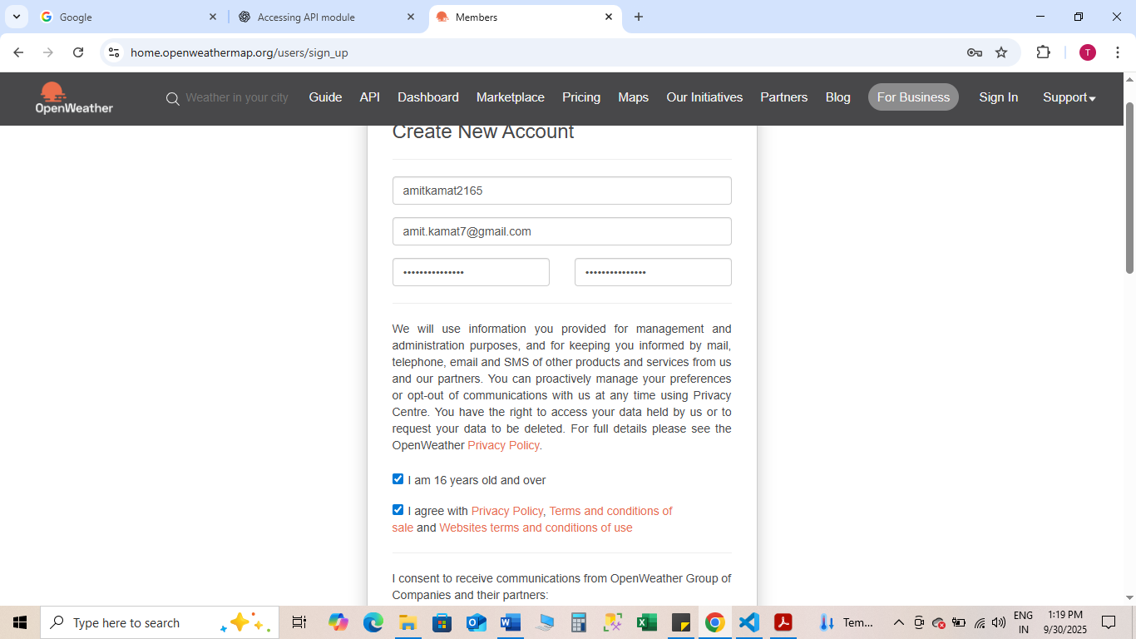
Pass Word-A**********
What is OpenWeather? — Definition
OpenWeather (OpenWeatherMap) is a web service that provides weather data — current weather, forecasts, and historical data — via HTTP APIs. Developers use it to fetch temperature, humidity, wind, weather descriptions, etc.
Authentication
OpenWeather uses an API key (a secret string) that you include in requests. Keep it private and do not push it to public repositories.

Example: Python requests — current weather

import requests
API_KEY = "e82*****06261477e12c71ff****8a4"
url = "https://api.openweathermap.org/data/2.5/weather"
params = {
"q": "Delhi",
"appid": API_KEY, # use your real key
"units": "metric"
}
response = requests.get(url, params=params)
data = response.json()
print("🔍 Full API Response:", data) # Debug line
# Only print weather if response is valid
if response.status_code == 200 and "main" in data:
print("City:", data["name"])
print("Temperature:", data["main"]["temp"], "°C")
print("Weather:", data["weather"][0]["description"])
else:
print("❌ Error:", data.get("message", "Unknown error"))

Real Life project on current weather using API

import requests
from datetime import datetime
API_KEY = " e82*****06261477e12c71ff****8a4"
BASE_URL = "https://api.openweathermap.org/data/2.5/weather"
def get_weather(city=None, lat=None, lon=None):
params = {
"appid": API_KEY,
"units": "metric"
}
# If city name is given, use it
if city:
params["q"] = city
# Otherwise, use latitude/longitude
elif lat is not None and lon is not None:
params["lat"] = lat
params["lon"] = lon
else:
return {"error": "Please provide either city name or latitude & longitude"}
response = requests.get(BASE_URL, params=params)
data = response.json()
if response.status_code == 200 and "main" in data:
# Convert UNIX timestamps to human-readable format
sunrise = datetime.fromtimestamp(data['sys']['sunrise']).strftime("%I:%M %p")
sunset = datetime.fromtimestamp(data['sys']['sunset']).strftime("%I:%M %p")
weather_info = {
"City": data.get("name", "Unknown"),
"Temperature": f"{data['main']['temp']} °C",
"Feels Like": f"{data['main']['feels_like']} °C",
"Weather": data['weather'][0]['description'],
"Humidity": f"{data['main']['humidity']}%",
"Wind Speed": f"{data['wind']['speed']} m/s",
"Sunrise": sunrise,
"Sunset": sunset
}
return weather_info
else:
return {"error": data.get("message", "Unknown error")}
# Example usage
if __name__ == "__main__":
# By city name
print("🔹 Singapore Weather:", get_weather(city="Singapore"))
# By latitude/longitude
print("🔹 Weather by coordinates:", get_weather(lat=1.3521, lon=103.8198))

Real Life project to develop a weather APP using API and GUI

import requests
from datetime import datetime
import tkinter as tk
from tkinter import messagebox
API_KEY = " e82*****06261477e12c71ff****8a4"
BASE_URL = "https://api.openweathermap.org/data/2.5/weather"
def get_weather(city):
params = {
"appid": API_KEY,
"q": city,
"units": "metric"
}
response = requests.get(BASE_URL, params=params)
data = response.json()
if response.status_code == 200 and "main" in data:
sunrise = datetime.fromtimestamp(data['sys']['sunrise']).strftime("%I:%M %p")
sunset = datetime.fromtimestamp(data['sys']['sunset']).strftime("%I:%M %p")
report = (
f" City: {data['name']}\n"
f" Temperature: {data['main']['temp']} °C\n"
f"🤔 Feels Like: {data['main']['feels_like']} °C\n"
f"⛅ Weather: {data['weather'][0]['description'].title()}\n"
f" Humidity: {data['main']['humidity']}%\n"
f"💨 Wind Speed: {data['wind']['speed']} m/s\n"
f" Sunrise: {sunrise}\n"
f" Sunset: {sunset}"
)
return report
else:
return f"❌ Error: {data.get('message', 'Unknown error')}"
# Function for button click
def show_weather():
city = city_entry.get()
if city.strip() == "":
messagebox.showwarning("Input Error", "Please enter a city name")
return
weather_report = get_weather(city)
result_label.config(text=weather_report)
# GUI Setup
root = tk.Tk()
root.title("🌦 Weather App")
root.geometry("400x350")
root.config(bg="#f0f8ff")
title_label = tk.Label(root, text="Weather App", font=("Arial", 16, "bold"), bg="#f0f8ff", fg="blue")
title_label.pack(pady=10)
city_entry = tk.Entry(root, font=("Arial", 14), justify="center")
city_entry.pack(pady=5)
get_button = tk.Button(root, text="Get Weather", font=("Arial", 12, "bold"), bg="lightblue", command=show_weather)
get_button.pack(pady=10)
result_label = tk.Label(root, text="", font=("Arial", 12), justify="left", bg="#f0f8ff", fg="black")
result_label.pack(pady=10)
root.mainloop()

Real life Example of News App using API and GUI

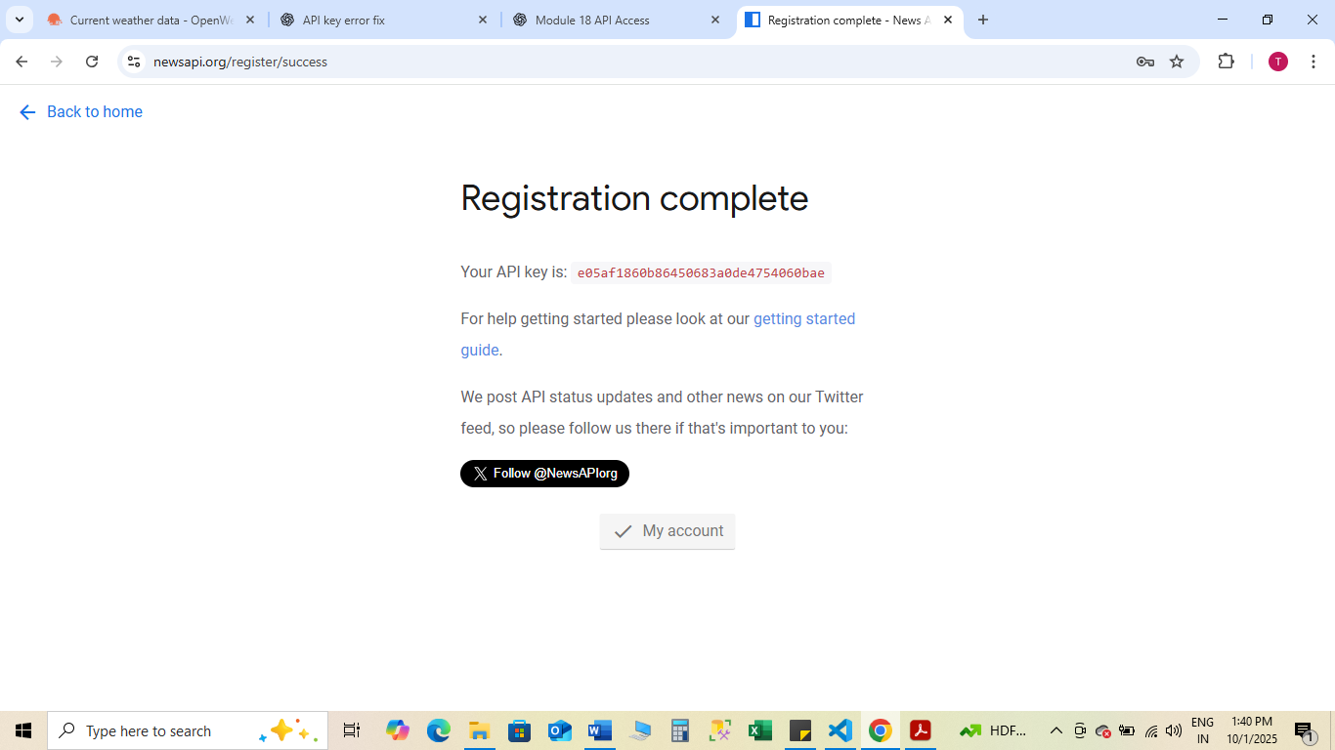

ID-S****_96
Pass Word-A***********

import requests
import tkinter as tk
from tkinter import ttk, messagebox

API_KEY = " e82*****06261477e12c71ff****8a4" # 🔑 Replace with your NewsAPI key
BASE_URL = "https://newsapi.org/v2/top-headlines"

def get_news(category="general"):
params = {
"apiKey": API_KEY,
"country": "us", # 'in' for India, 'us' for USA, etc.
"category": category
}
response = requests.get(BASE_URL, params=params)
data = response.json()

if data.get("status") == "ok":
articles = data.get("articles", [])
headlines = [f"📰 {a['title']}" for a in articles if a["title"]]
return headlines[:10] if headlines else ["No news found."]
else:
return [f"❌ Error: {data.get('message', 'Unknown error')}"]

def show_news():
category = category_var.get()
headlines = get_news(category)
news_list.delete(0, tk.END) # clear old news
for h in headlines:
news_list.insert(tk.END, h)

# GUI Setup
root = tk.Tk()
root.title("📰 News App")
root.geometry("500x400")
root.config(bg="#f8f9fa")

title_label = tk.Label(root, text="Latest News Headlines", font=("Arial", 16, "bold"), bg="#f8f9fa", fg="blue")
title_label.pack(pady=10)

# Dropdown for category
category_var = tk.StringVar(value="general")
categories = ["general", "business", "sports", "technology", "entertainment", "health", "science"]
category_menu = ttk.Combobox(root, textvariable=category_var, values=categories, state="readonly", font=("Arial", 12))
category_menu.pack(pady=5)

get_button = tk.Button(root, text="Get News", font=("Arial", 12, "bold"), bg="lightblue", command=show_news)
get_button.pack(pady=10)

# Listbox to display news
news_list = tk.Listbox(root, font=("Arial", 12), width=60, height=12, bg="white", fg="black")
news_list.pack(pady=10)

root.mainloop()

Real Life project to develop a TIMES OF INDIA new APP using API and GUI
import requests
import tkinter as tk
from tkinter import ttk, messagebox
import webbrowser

API_KEY = " e82*****06261477e12c71ff****8a4" # 🔑 Replace with your NewsAPI key
BASE_URL = "https://newsapi.org/v2/top-headlines"

def get_news(category="general", source=None):
params = {
"apiKey": API_KEY,
"pageSize": 10 # fetch top 10 articles
}

if source: # fetch from a specific source like TOI
params["sources"] = source
else: # fetch by country & category
params["country"] = "in"
params["category"] = category

response = requests.get(BASE_URL, params=params)
data = response.json()

if data.get("status") == "ok":
articles = data.get("articles", [])
# Each headline stores title + URL for clicking
headlines = [{"title": a["title"], "url": a["url"]} for a in articles if a["title"]]
return headlines if headlines else [{"title": "No news found.", "url": None}]
else:
return [{"title": f"❌ Error: {data.get('message', 'Unknown error')}", "url": None}]

def show_news():
news_list.delete(0, tk.END)
if source_var.get() == "Times of India":
articles = get_news(source="the-times-of-india")
else:
category = category_var.get()
articles = get_news(category=category)

for article in articles:
news_list.insert(tk.END, article["title"])
# Store URLs for opening
global current_articles
current_articles = articles

def open_article(event):
selection = news_list.curselection()
if selection:
index = selection[0]
url = current_articles[index]["url"]
if url:
webbrowser.open(url)

# GUI Setup
root = tk.Tk()
root.title("📰 India News App")
root.geometry("600x450")
root.config(bg="#f8f9fa")

title_label = tk.Label(root, text="India News Headlines", font=("Arial", 16, "bold"), bg="#f8f9fa", fg="blue")
title_label.pack(pady=10)

# Source selection
source_var = tk.StringVar(value="India")
source_menu = ttk.Combobox(root, textvariable=source_var, values=["India", "Times of India"], state="readonly", font=("Arial", 12))
source_menu.pack(pady=5)

# Category dropdown
category_var = tk.StringVar(value="general")
categories = ["general", "business", "sports", "technology", "entertainment", "health", "science"]
category_menu = ttk.Combobox(root, textvariable=category_var, values=categories, state="readonly", font=("Arial", 12))
category_menu.pack(pady=5)

get_button = tk.Button(root, text="Get News", font=("Arial", 12, "bold"), bg="lightblue", command=show_news)
get_button.pack(pady=10)

# Listbox for headlines
news_list = tk.Listbox(root, font=("Arial", 12), width=80, height=15, bg="white", fg="black")
news_list.pack(pady=10)
news_list.bind("<Double-Button-1>", open_article) # double-click to open article

current_articles = [] # store currently displayed articles

root.mainloop()

Uses Google News RSS (live feed, always current) instead of NewsAPI.
import tkinter as tk
from tkinter import ttk, messagebox
import webbrowser
import feedparser # pip install feedparser

# --- Function to get live Google News RSS feeds ---
def get_news(category="top"):
category_map = {
"top": "",
"business": "business",
"sports": "sports",
"technology": "technology",
"entertainment": "entertainment",
"health": "health",
"science": "science",
}

url = f"https://news.google.com/rss?hl=en-IN&gl=IN&ceid=IN:en"
if category != "top":
url = f"https://news.google.com/rss/headlines/section/topic/{category_map[category]}?hl=en-IN&gl=IN&ceid=IN:en"

feed = feedparser.parse(url)
headlines = [{"title": entry.title, "url": entry.link} for entry in feed.entries]
return headlines if headlines else [{"title": "No news found.", "url": None}]

# --- Function to display fetched news ---
def show_news():
news_list.delete(0, tk.END)
category = category_var.get()
articles = get_news(category)

global current_articles
current_articles = articles

for article in articles:
news_list.insert(tk.END, article["title"])

# --- Function to open selected news article ---
def open_article(event):
selection = news_list.curselection()
if selection:
index = selection[0]
url = current_articles[index]["url"]
if url:
webbrowser.open(url)

# --- GUI Setup ---
root = tk.Tk()
root.title("📰 Live India News App")
root.geometry("700x500")
root.config(bg="#f8f9fa")

title_label = tk.Label(root, text="India News Headlines (Live from Google News)", font=("Arial", 16, "bold"), bg="#f8f9fa", fg="blue")
title_label.pack(pady=10)

category_var = tk.StringVar(value="top")
categories = ["top", "business", "sports", "technology", "entertainment", "health", "science"]
category_menu = ttk.Combobox(root, textvariable=category_var, values=categories, state="readonly", font=("Arial", 12))
category_menu.pack(pady=5)

get_button = tk.Button(root, text="Get News", font=("Arial", 12, "bold"), bg="lightblue", command=show_news)
get_button.pack(pady=10)

news_list = tk.Listbox(root, font=("Arial", 12), width=90, height=18, bg="white", fg="black")
news_list.pack(pady=10)
news_list.bind("<Double-Button-1>", open_article)

current_articles = []

# Load top news initially
show_news()

root.mainloop()

